Thank you for agreeing to set up ongoing donations to UCE using preauthorized debits. We need you to answer a few questions to get you started:

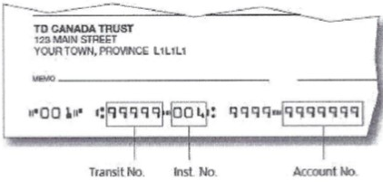
1. First of all, what is your bank account information? Send us a picture of a check with the word “VOID” written across the face or send us the account information you get from your bank (just ask a teller for an Info Sheet for Preauthorized Debits).

Or you can write your bank account number out here:
(see the image to see how to find these numbers on your check).
Transit # _ _ _ _ _ Bank # _ _ _ Account # _ _ _ _ _ _ _ _ _ _ _ _ _

2. How much would you like to donate each month? $_______/month

3. When would you like the donation to be taken from you bank account?
a. After the first of the month ____
b. After the fifteenth of the month ____

4. When would you like to start the preauthorized debits? The church financial year starts on July 1st each year. You can have the debits start on July 1st or on another date of your choosing. When would like automatic debits to start?
a. Please start immediately ____
b. Please start on July 1st ____
c. Please start on this date _______________________

5. And finally, please confirm your address (if not already on your check) so that we can send a tax receipt for your donation.
a. Your Name _______________________________
b. Your Address _____________________________
c. City and Postal Code _______________________
d. Your phone number _______________________

6. Your signature please _____________________________________ date ____________________

Here are the terms and conditions of your preauthorized debits at UCE. This agreement follows Rule H1 of the Canadian Payments Association https://www.payments.ca/sites/default/files/h1eng.pdf .

- This your preauthorized debit (PAD) agreement.
- By submitting this form you authorize the Unitarian Church of Edmonton to withdraw funds from the account you have given us.
- This is a personal preauthorized debit (Rule H1 section 5). You will receive a charitable donation tax receipt each year for your donations to UCE including your preauthorized debits, as well as for any other identified donations that you give to the church.
- The monthly debit amount will be as you indicated above. This amount may be changed each year by submitting the new amount on a pledge form during canvass. The amount may also be changed by contacting the canvass chair or the church office.
- Amounts will be withdrawn monthly on either the first or the 15th of the month as you instructed.
- Your preauthorized debits to UCE will continue until you tell us to stop. You can stop these payments by email, phone, or by mail to the canvass chair or to the church office. Payments will be stopped as soon as possible after we receive your instructions.
- To contact the canvass chair call Andrew Mills at 780-918-3288 or email andrew@misc.ca. To contact the church office call 780-454-8073 or email chadmin@uce.ca. Regular mail can be sent to UCE, 10804-119 St NW, Edmonton, Alberta, T5H 3P2.
- You have certain recourse rights if any debit does not comply with this agreement. For example, you have the right to receive reimbursement for any debit that is not authorized or is not consistent with this PAD agreement.
- This agreement follows Rule H1, Appendix II of the Canadian Payments Association. https://www.payments.ca/sites/default/files/h1eng.pdf
- You agree to waive the confirmation/pre-notification requirements of Rule H1.

